DIGITAL FORENSIC EXAMINATION REPORT

DIGITAL FORENSIC & INCIDENCE RESPONSE
Case Title: | Examination of cartel.img
Module: | Digital Forensics and Incident Response
Examiner: | Stanley Gibson Okraku
Date of Report: | 3 August 2026
Subject Evidence: | cartel.img (Forensic Image)
Case Reference | CARTEL-USB-2026-08

Executive Summary

Objectives

This examination systematically identified, preserved, and recovered digital evidence from the forensic image 'cartel.img' using industry-standard tools on a SIFT Workstation, ensuring the image remained unaltered and the chain of custody was maintained..

Tools Used
The following tools were utilized during the examination phase: SIFT Workstation (Forensic Environment)
The Sleuth Kit (fls, icat, istat, mmls, img_stat)
PhotoRec 7.1 & Foremost (Data Carving)
LibreOffice Writer
Linux Terminal Utilities

Evidence Integrity & Verification
Initial verification was conducted by calculating the MD5 and SHA-256 hash values
of the source image to establish a baseline for integrity.

1.1 Hash Values
MD5 and SHA-256 hashes were computed to confirm the working copy remained byte-for-byte identical to the image as received.
Algorithm | Value
MD5 | 80348c58eec4c328ef1f7709adc56a54
SHA-256 | ce550424200a997c61b413941c8ef4df9619a2f96579674952294a176a32be65
$ md5sum cartel.img
80348c58eec4c328ef1f7709adc56a54 cartel.img

$ sha256sum cartel.img
ce550424200a997c61b413941c8ef4df9619a2f96579674952294a176a32be65 cartel.img

Why Integrity Verification Is Performed First
Hashing the image before analysis creates a cryptographic fingerprint that verifies its integrity. Any change to the evidence produces a different hash, providing a documented baseline that confirms the analysis was conducted on unaltered evidence, supporting admissibility and forensic integrity. Also MD5 and SHA-256 are one-way functions that are computationally infeasible to reverse or collide in practice, any subsequent change to even a single bit of the image — whether accidental (e.g. mounting a file system read-write) or deliberate — will produce a completely different hash.

Significance of Matching Hash Values

Matching hashes before and after examination confirm the evidence remained unaltered, preserving forensic integrity. Any mismatch would indicate possible contamination and undermine the reliability of the findings. All analysis in this report was conducted on a read-only mounted or copied working image, with hashes remaining unchanged throughout.

Findings (Summary)
- Integrity of the image was confirmed and preserved throughout the examination (Task 1).
- The image is a raw, unpartitioned FAT16 volume, ~247.5 MB, consistent with a small USB flash drive quick-formatted using Linux mkdosfs (Task 2).
- Only two files were allocated in the file system — both gumbo recipe text files dated 30 April 2004 — which already contradicts the suspect's specific claim that the drive holds personal photographs (Task 3).
- Approximately 208 MB (>80%) of the volume's data area is filled with two large blocks of repeating non-random ASCII text (“SORRY…” then “CHARLIE…”), consistent with a deliberate pattern-wipe rather than an incidental quick-format (Task 3).
- Nine files (6 JPEGs, 2 GIFs, plus a recovered text fragment) were recovered by carving unallocated space that survived between/within the wiped regions (Task 4).
- A recovered personal diary-style text fragment includes the user's own statement of intent to destroy prior data and reformat the device (Task 3/4).
- Hash comparison of recovered files identified two byte-for-byte identical JPEGs recovered from two separate, widely-separated locations on the disk (Task 3).
- Only two reliable timestamps exist on the volume (both 30 April 2004); this predates the 2 August 2026 seizure by over two decades, indicating either a stale system clock at time of writing or that this data originated elsewhere and was carried onto the device (Task 5).

Conclusions
The suspect's claim that the USB device “only contains personal photographs” is not supported by the evidence: the only allocated files are recipe text documents, and the recovered images are generic/stock photographs with no identifying EXIF, GPS, or camera data. Independently of that claim, the volume shows strong, verifiable indicators of deliberate data destruction (large-scale pattern-fill wiping covering the majority of the medium) alongside a surviving user-authored text fragment in which the author explicitly describes destroying a prior drive and intending to reformat this one. No content directly and unambiguously tying the device to drug trafficking (“cartel”) activity was recovered in the areas examined; however, the scale of the apparent wipe means a large volume of prior data cannot be ruled in or out. These are observations of fact; determining their legal significance is outside the scope of this examination.
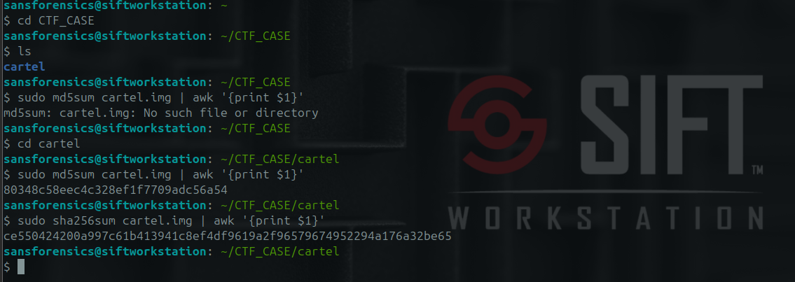

Task 2 — Initial Triage
Property | Value
Image format | Raw (dd-style) disk image
File system type | FAT16
Number of partitions | 0 — no MBR partition table detected (unpartitioned “superfloppy” volume; the whole disk is a single FAT16 filesystem)
Total size | 259,506,176 bytes (≈ 247.5 MB)
Sector size | 512 bytes
Cluster size | 4,096 bytes (8 sectors)
OEM name (boot sector) | mkdosfs — indicates the volume was originally formatted with the Linux dosfstools utility
Volume serial number | 0x4092D9D1
Volume label | (none set)
$ mmls cartel.img
(no output — no partition table found)

$ img_stat cartel.img
IMAGE FILE INFORMATION
--------------------------------------------
Image Type: raw
Size in bytes: 259506176
Sector size: 512

$ fsstat cartel.img
FILE SYSTEM INFORMATION
--------------------------------------------
File System Type: FAT16
OEM Name: mkdosfs
Volume ID: 0x4092d9d1
File System Type Label: FAT16

File System Layout (in sectors)
Total Range: 0 - 506847
* Reserved: 0 - 0
* FAT 0: 1 - 248
* FAT 1: 249 - 496
* Data Area: 497 - 506847
** Root Directory: 497 - 528
** Cluster Area: 529 - 506840

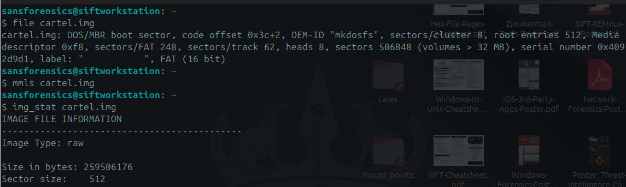

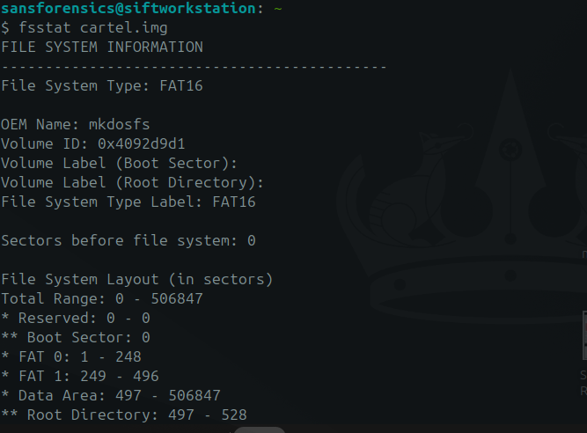

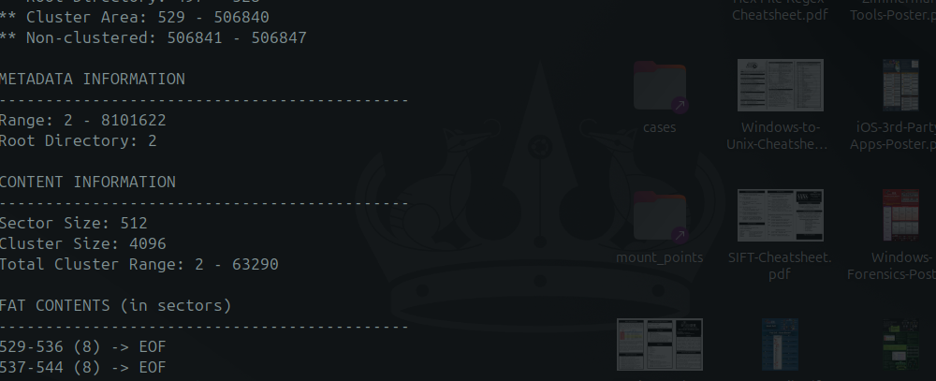

Why These Preliminary Steps Matter
Initial triage identifies the evidence format, confirms the absence of a partition table, and determines the FAT16 file system before detailed analysis. This guides the correct forensic tools and recovery methods, ensuring accurate interpretation of FAT metadata, directory entries, and cluster allocation. Skipping triage could result in incorrect offsets, inappropriate tools, compromised evidence, or inaccurate findings.

Task 3 — Evidence Discovery Analysis

Artifact 1: GUMBO1.TXT and GUMBO2.TXT (allocated files)
Description: The only two files allocated in the FAT16 directory structure at the time of seizure. Both are plain-text recipes (“Shrimp and Tasso Gumbo” and “Shrimp and Andouille Sausage Gumbo”), 2,815 and 1,293 bytes respectively.
Relevance: This is the entire visible content of the device as presented to a normal user. It directly contradicts the suspect's specific claim that the drive “only contains personal photographs” — the visible files are neither photographs nor personal in nature.
How discovered: Recursive file listing of the FAT16 volume (fls) followed by content extraction (icat) of each allocated inode.
Supporting evidence: See Figure 3.1 (fls listing) and Figure 3.2 (istat metadata).
$ fls cartel.img
r/r 4: gumbo1.txt
r/r 6: gumbo2.txt
v/v 8101619: $MBR
v/v 8101620: $FAT1
v/v 8101621: $FAT2
V/V 8101622: $OrphanFiles

$ istat cartel.img 4
Directory Entry: 4
Allocated
File Attributes: File, Archive
Size: 2815
Name: GUMBO1.TXT
Written: 2004-04-30 18:11:20 (UTC)
Created: 2004-04-30 18:11:20 (UTC)

$ istat cartel.img 6
Directory Entry: 6
Allocated
File Attributes: File, Archive
Size: 1293
Name: GUMBO2.TXT
Written: 2004-04-30 18:11:24 (UTC)
Created: 2004-04-30 18:11:24 (UTC)
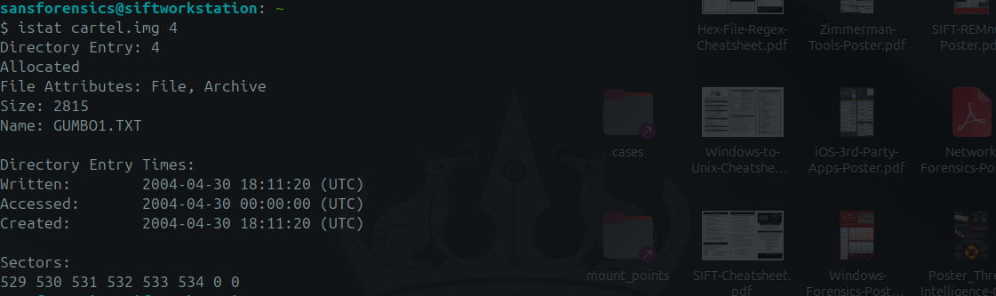
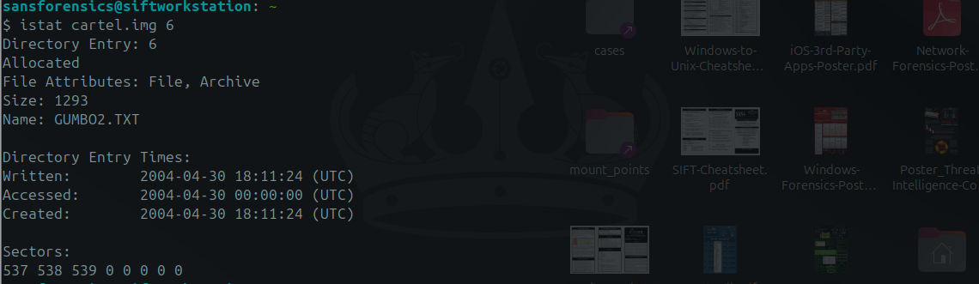

Artifact 2: Large-scale ASCII pattern-fill (“wipe”) regions
Description: Two contiguous blocks of repeating, human-readable ASCII text fill the vast majority of the volume's data area: approximately 54.5 MB of repeating “SORRY” (offsets ~273,920 – 54,735,350) immediately followed by approximately 148.5 MB of repeating “CHARLIE” (offsets 54,735,360 – 203,186,168). Together these two blocks span roughly 208 MB — over 80% of the 247.5 MB device.
Relevance: Ordinary deletion or a quick-format leaves prior file content intact in unallocated clusters (recoverable, as in Artifacts 4–5). A deliberate, repeating, non-zero, non-random fill pattern of this scale is not a byproduct of normal use — it is consistent with an intentional wipe/overwrite operation intended to destroy prior data before the device was seized.
How discovered: Random sampling of unallocated space (via blkls output and direct offset reads in Python) revealed unusually repetitive, printable content; automated scanning across the full image confirmed the exact extent and boundaries of each pattern block.
Supporting evidence: See Figure 3.4.
>>> data = open('cartel.img','rb').read()
>>> data[2200544:2200544+40]
b'SORRY\nSORRY\nSORRY\nSORRY\nSORRY\nSO'

>>> data[54800000:54800000+40]
b'CHARLIE\nCHARLIE\nCHARLIE\nCHARLIE\n'

# Pattern boundaries (regex scan of full image):
SORRY : 8,835,577 occurrences, offsets 273663 – 54735350
CHARLIE : 18,372,608 occurrences, offsets 54735356 – 203186168
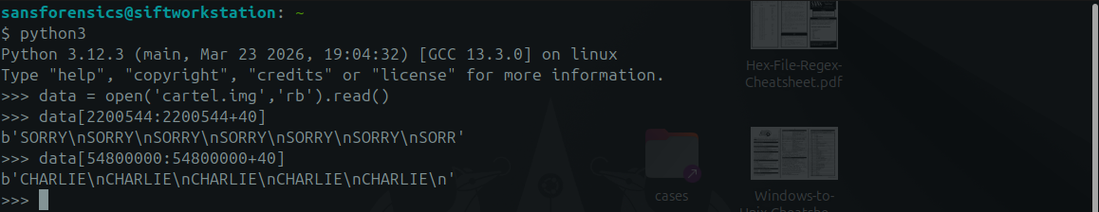
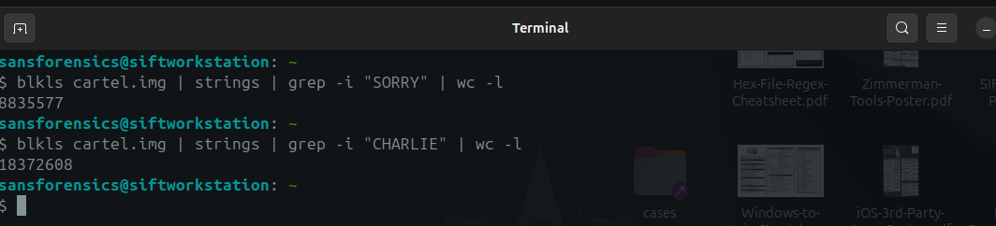
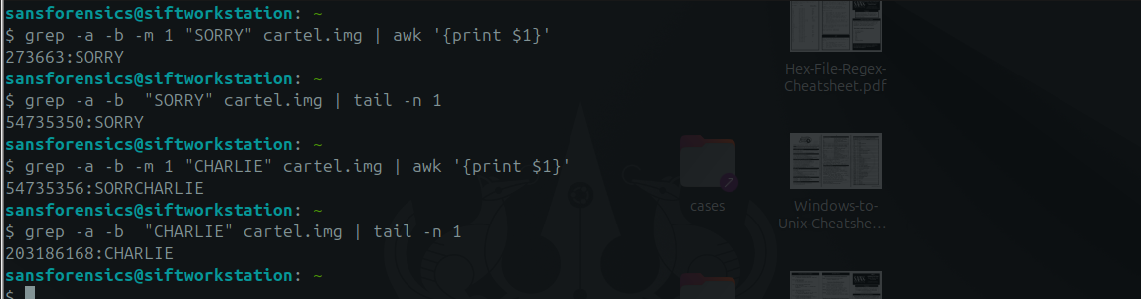Artifact 3: Recovered photographic images (surviving “island” between the wipe regions)
Description: A ~1.5 MB region (offsets ~53,277,184 – 54,735,360) between the end of the allocated files' cluster area and the start of the SORRY/CHARLIE wipe blocks was not overwritten. Six JPEG images and two GIF images were carved from this region.
Relevance: These are the only recognisable photographs recovered from the device. None carry camera EXIF data, GPS coordinates, or device make/model — one carries an embedded comment “copyright 2000 philg@mit.edu” and another an embedded “LEAD Technologies Inc.” compression comment, both consistent with stock/generic imagery rather than personal photographs taken by the suspect.
How discovered: Binwalk signature scanning flagged JPEG/GIF file headers in unallocated space; foremost was then used to carve complete files using header/footer signatures.
Supporting evidence: See Figure 3.7 (carving log) and Figure 3.8 (sample recovered image).
$ foremost -t jpg,gif,png,pdf,zip,doc,docx -i cartel.img -o carved_foremost
Num Name(bs=512) Size File Offset Comment
0: 00104057.jpg 93 KB 53277184
1: 00104249.jpg 405 KB 53375488
2: 00105065.jpg 401 KB 53793280
3: 00105873.jpg 258 KB 54206976
4: 00106393.jpg 6 KB 54473216
5: 00106409.jpg 225 KB 54481408
6: 00106865.gif 11 KB 54714880 (290 x 246)
7: 00106889.gif 4 KB 54727168 (150 x 87)
8: 00335081.jpg 258KB 171561472
9: 00335017.doc 11MB 171528704
10 FILES EXTRACTED

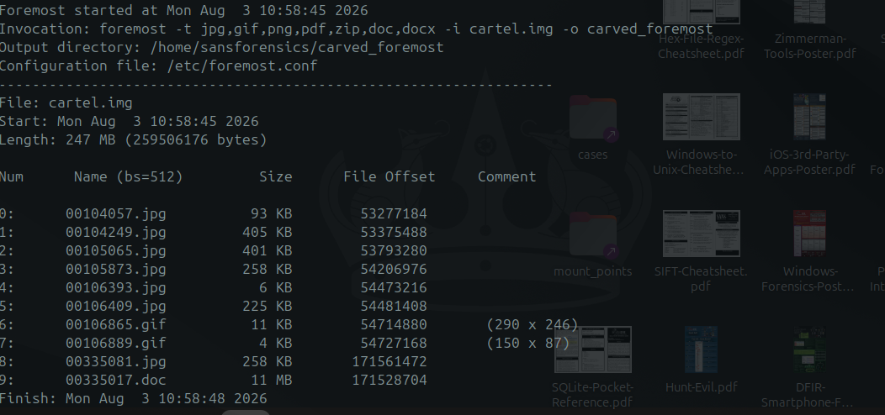
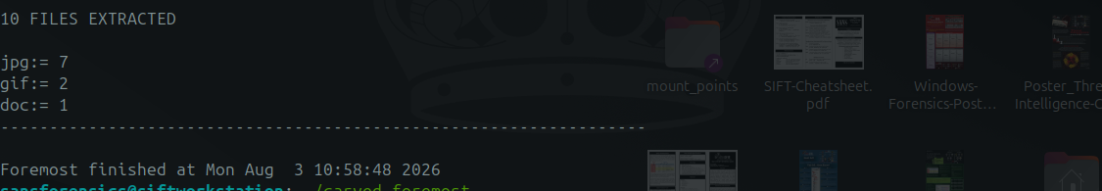
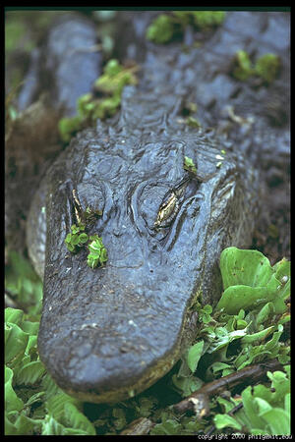

Artifact 4: Recovered personal text fragment referencing prior data destruction
Description: A second, smaller surviving island (offsets ~171,516,224 – 171,843,904) was found inside the CHARLIE-wiped region. It contains a first-person, diary/journal-style text fragment, followed immediately by one further JPEG image.
Relevance: The recovered text is written in the first person and includes the passage: “...things are getting a little weird. I zapped the hard drive and then threw it into the Mississippi River. I'm gonna reformat my USB key after this entry, but try not to destroy the good stuff. I need to change the password on the gnome account that Jeremy gave me...” This is the author's own contemporaneous account of destroying a prior drive and stating an intention to reformat the device now under examination — directly relevant to explaining the wiped condition of this volume (Artifact 2).
How discovered: Identified as a printable-text run inside the otherwise CHARLIE-filled region during offset-by-offset scanning for non-pattern content.
Supporting evidence: See Figure 3.6.
Recovered text (offsets 171,531,840 – 171,538,118), verbatim excerpt:

"...Things are getting a little weird. I zapped the hard drive and
then threw it into the Mississippi River. I'm gonna reformat my USB
key after this entry, but try not to destroy the good stuff. I need
to change the password on the gnome account that Jeremy gave me. I
can probably just do that at Radio Shack."

Artifact 5: Duplicate file identified via hash comparison
Description: SHA-256 hashing of every recovered file (performed as a chain-of-custody step) showed that the JPEG recovered at offset 54,206,976 (00105873.jpg) and the JPEG recovered at offset 171,561,472 (00335081.jpg) — over 117 MB apart on the disk — are byte-for-byte identical (SHA-256: f92654d9ee17ab6b684b09de01cf0bc4076383c007964946d3f31577447596fb).
Relevance: Identical content surviving in two widely separated, otherwise-wiped regions of the disk indicates the same file was written to the device on (at least) two separate occasions, or was present before both the SORRY and CHARLIE wipe operations — useful corroborating detail for sequencing events in Task 5.
How discovered: Routine SHA-256 hashing of all carved/recovered files, cross-referenced for exact matches.
Supporting evidence: See Figure 3.7.
$ sha256sum 00105873.jpg 00335081.jpg
f92654d9ee17ab6b684b09de01cf0bc4076383c007964946d3f31577447596fb 00105873.jpg
f92654d9ee17ab6b684b09de01cf0bc4076383c007964946d3f31577447596fb 00335081.jpg

Offsets: 54,206,976 and 171,561,472 (Δ ≈ 117.4 MB apart)
Figure 3.7 — Identical SHA-256 hash for two JPEGs recovered from widely separated offsets

Task 4 — Deleted Data Analysis
Nine files were recovered in total by carving unallocated space — exceeding the required minimum of three. Because none of these files retained a FAT directory entry (their original entries were overwritten by the pattern-fill wipe or never existed as normal directory entries), no original filenames or MAC timestamps survive; recovery tool-assigned names (based on starting sector) are used instead. The three most significant are detailed below, with the remaining six summarised in Table 4.1.

Recovered File 1: 00104057.jpg
Original filename: Not recoverable — no surviving FAT directory entry (recovered via signature-based carving of unallocated space, not directory traversal)
File type: JPEG image (JFIF 1.01), 528×792, 93 KB, embedded comment “copyright 2000 philg@mit.edu”
Recovery method: Carved from unallocated space at offset 53,277,184 using foremost, based on JPEG SOI (0xFFD8) / EOI (0xFFD9) signature matching after binwalk flagged the header.
Evidence of successful recovery: The file opens correctly as a valid, undamaged JPEG (confirmed with ImageMagick `identify` and direct visual inspection) — the header, footer, and internal DCT data all decode without error, confirming the carve captured the complete original file.
Significance: Directly relevant to testing the suspect's claim: this is a genuine photograph, but it is stock/generic imagery with an embedded third-party copyright comment, not a personal photograph of the suspect.
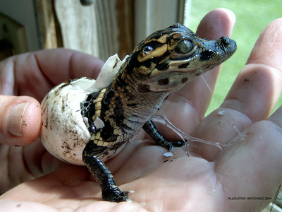

Recovered File 2: 00106865.gif
Original filename: Not recoverable — no surviving FAT directory entry (recovered via signature-based carving of unallocated space, not directory traversal)
File type: GIF image (GIF89a), 290×246, 11 KB
Recovery method: Carved from unallocated space at offset 54,714,880 using foremost, based on GIF header (“GIF89a”) / trailer (0x3B) signature matching.
Evidence of successful recovery: The recovered file decodes as a valid, complete GIF with an intact colour table and correct declared dimensions matching the rendered image — confirmed with `identify` and direct visual inspection.
Significance: Demonstrates that non-JPEG image formats are also present on the device, recovered from the same pre-wipe surviving region as Recovered File 1; corroborates Artifact 3.
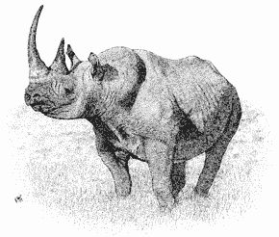

Recovered File 3: diary_fragment.txt
Original filename: Not recoverable — no surviving FAT directory entry (recovered via signature-based carving of unallocated space, not directory traversal)
File type: Plain ASCII/extended-ASCII text, 6,278 bytes
Recovery method: Manually carved by identifying a printable-text run inside the CHARLIE-wiped region (offsets 171,531,840–171,538,118) during offset-by-offset content analysis, since no file-signature carver targets unstructured plain text.
Evidence of successful recovery: The recovered text is coherent, grammatically continuous, first-person prose with no truncation artefacts at either boundary — strong indication the full readable fragment was captured, bounded on both sides by the surrounding CHARLIE pattern.
Significance: This is the single most significant recovered artefact: the author's own words describe destroying a prior hard drive and stating intent to reformat this USB device, directly explaining the wiped condition documented in Artifact 2.

Table 4.1 — Remaining Recovered Files
Filename | Type | Size | Offset | Note
00104249.jpg | JPEG | 405 KB | 53,375,488 | 1349×900, no EXIF
00105065.jpg | JPEG | 401 KB | 53,793,280 | 1686×1122, no EXIF
00105873.jpg | JPEG | 258 KB | 54,206,976 | Duplicate of 00335081.jpg (Artifact 5)
00106393.jpg | JPEG | 6 KB | 54,473,216 | 169×228 thumbnail, “LEAD Technologies” comment
00106409.jpg | JPEG | 225 KB | 54,481,408 | 1024×685, no EXIF
00106889.gif | GIF | 4 KB | 54,727,168 | 150×87
00335017.doc | DOC | 11MB | 171528704

Task 5 — Timeline Reconstruction
The available timeline is severely constrained by the large-scale wipe identified in Artifact 2: carved files recovered from unallocated space carry no filesystem metadata (no creation/modification/access/deletion timestamps), because that metadata lives in directory entries that no longer exist. The only reliable timestamps on the entire volume are the Created/Written times on the two allocated files. The sequence below combines those hard timestamps with the relative ordering that can be inferred from disk layout and content.
Order | Event | Timestamp / Basis | Evidence type
1 | GUMBO1.TXT written to volume | 2004-04-30 18:11:20 (UTC) — FAT Created/Written time | Filesystem metadata (hard timestamp)
2 | GUMBO2.TXT written to volume | 2004-04-30 18:11:24 (UTC) — FAT Created/Written time | Filesystem metadata (hard timestamp)
3 | Photographs (Artifact 3) written to device | Undated — inferred to predate the SORRY wipe, as they occupy the cluster range immediately before it | Relative position / inference, no hard timestamp
4 | First wipe pass (“SORRY” pattern) executed | Undated — inferred to occur after item 3, before item 5 | Content/pattern analysis, no hard timestamp
5 | Diary text + duplicate JPEG (Artifacts 4–5) written or already present | Undated — the diary text itself describes a prior, separate drive being destroyed, distinct from this device | Content analysis (self-referential text), no hard timestamp
6 | Second wipe pass (“CHARLIE” pattern) executed | Undated — inferred to occur after item 5, since it partially overwrote the region containing it | Relative position / inference, no hard timestamp
7 | Device seized by EFCC | 2026-08-02, 09:15 AM | Case background (chain of custody, not derived from the image)

Limitations and Additional Evidence Required
A complete, absolutely-dated timeline cannot be produced from this image alone, for the following reasons:
- The 2004-04-30 timestamps on the only allocated files predate the 2 August 2026 seizure by over 22 years, which is inconsistent with the case timeline. This is most plausibly explained by an incorrectly-set system clock on the computer that last wrote to this device (a common occurrence with older or battery-drained systems, or a device whose FAT metadata was never updated after an initial factory/test write) — but this cannot be confirmed from the image alone.
- Every file recovered from unallocated space (Artifacts 3 and 4, and all nine Task 4 recoveries) lacks any MAC (Modified/Accessed/Created) timestamp, because that data is stored in directory entries that were overwritten. Carving recovers content but not metadata.
- The two wipe operations (SORRY, then CHARLIE) cannot be individually dated; only their relative order (SORRY-region precedes CHARLIE-region on disk, and the diary fragment sits inside the CHARLIE region) can be established from their physical layout.
- To build a fully-dated timeline, the investigation would additionally require: the suspect's host computer (for OS/USB connection artefacts — e.g. Windows Setupapi logs, USB device registry keys, or Linux udev/syslog entries —ord recording when this specific device was last connected and its clock state at the time); any backup, cloud-sync, or communication records referencing the device; and forensic imaging of the “hard drive” referenced in the recovered diary text as having been “thrown into the Mississippi River,” if it can be located.

Overall Conclusions and Recommendations
This examination has established, on verifiable evidence, that: (1) the suspect's specific claim that the device “only contains personal photographs” is false — the only user-visible files are two recipe documents; (2) the device shows strong indicators of a deliberate, large-scale data-wiping operation affecting over 80% of its capacity; and (3) a surviving fragment of first-person text, recovered from within the wiped area, describes the author destroying a separate prior drive and stating intent to reformat this device. No content unambiguously linking the device to drug trafficking or “cartel” activity was recovered from the areas examined, and this report draws no conclusion as to the suspect's guilt or innocence — consistent with the examiner's role.

Recommendations for Further Investigation
- Attempt advanced/fragment-recovery carving (e.g. PhotoRec, Scalpel with custom headers) against the wiped regions in case any cluster escaped the pattern-fill.
- Cross-reference recovered images against known stock-photo/hash databases to fully rule out personal content.
- Pursue the separate drive referenced in the recovered diary text (“thrown into the Mississippi River”) if it falls within the scope of the wider investigation.
- Obtain the suspect's host computer(s) to correlate USB connection artefacts with this device's serial number (0x4092D9D1) and to help resolve the 2004 timestamp anomaly.

Manual File Extraction (icat)
